**BRAIN TUMOR RECOGNITION USING DEEP LEARNING**

**BY**

**OLUKOTUN STEPHEN TIMILEYIN**

**20/47CS/01167**

**AUGUST 2024**



**BRAIN TUMOR RECOGNITION USING DEEP LEARNING**

**BY**

**OLUKOTUN STEPHEN TIMILEYIN**

**20/47CS/01167**

A Project Report Submitted to the Department of Electrical and Computer Engineering, Faculty of Engineering and Technology, Kwara State University, Malete, in Partial Fulfilment of the Requirements for the Award of Bachelor of Engineering (B.Eng.) Degree in Electrical and Electronics Engineering.

**AUGUST 2024**

# DECLARATION

I hereby declare that this project titled “**Brain Tumor Recognition Using Deep Learning**” is my own work and has not been submitted by any other person for any degree or qualification at any higher institution. I also declare that the information provided therein are mine and those that are not mine are properly acknowledged.

David Victor

_____________________ _____________________

Name of Student Signature and Date

# CERTIFICATION

This is to certify that this project titled “**Brain Tumor Recognition Using Deep Learning**” was carried out by **David Victor Jesugbemi**. The project has been read and approved as meeting the requirements for the award of Bachelor of Engineering (B.Eng.) Degree in Electrical and Electronics Engineering in the Department of Electrical and Computer Engineering, Faculty of Engineering and Technology, the Kwara State University, Malete.

________________________ _________________

Engr. Dr. Lekan Ogunbiyi Date

Supervisor

________________________ _________________

Engr. Dr. L. M. Adesina Date

Head of Department

________________________ __________________

External Examiner Date

# DEDICATION

This project is dedicated to God Almighty who has been there right from the beginning of my course of study to this point. Special dedication also to my ever parents, for their relentless support and compassion towards me during this time. Furthermore, I want to dedicate this report also to Mrs Adeboye, Mr Adeboye, my families, friends and lecturer for their continual impact of help and knowledge.

# ACKNOWLEDGEMENTS

I want to thank almighty God for his guidance and given understanding. Special thanks to my supervisor Dr. Olalekan Ogunbiyi for believing in me, his guidance, profound mentorship and unwavering supports all through my work.

I also take this opportunity to sincerely express my appreciation to all my lecturers in the Department of Electrical and Computer Engineering, Kwara State University for their constant support in making this project a success. I would never have been able to accomplish any of my objectives without the support of some important personalities in my life, the Adeboyes family, among others who are my source of motivation.

My hearty gratitude to my parents Mr. and Mrs. Adeboye, my wonderful brothers, and sister for looking up to my success, which has always given me the challenge to achieve more. Thanks for all you do now and always.

# TABLE OF CONTENTS

**FRONT PAGE………………………………………………………………………………..i**

**TITLE PAGE…………………………………………………………………………………ii**

**DECLARATION iii**

**CERTIFICATION iv**

**DEDICATION v**

**ACKNOWLEDGEMENTS vi**

**TABLE OF CONTENTS vii**

**LIST OF FIGURES x**

**ABSTRACT xiii**

**CHAPTER ONE 1**

**INTRODUCTION AND REPORT OVERVIEW 1**

**1.1 Introduction 1**

**1.2 Motivation 2**

**1.3 Problem Statement 3**

**1.4 Aim And Objective 4**

**1.5 Justification Of The Study 4**

**CHAPTER TWO 5**

**LITERATURE REVIEW AND RELEVANT CONCEPTS 5**

**2.0 Literature Review 5**

**2.1 Theoretical Concept Of Project 7**

**2.1.0 What Is The Brain? 7**

**2.1.2 Anatomy And Function 7**

**2.1.3 Brain Tumor 10**

**2.1.4 Magnetic Resonance Imaging 16**

**2.2 Digital Image Proccessor 18**

**2.2.1 Digital Image Processing 19**

**2.2.2 Type Of Image 23**

**2.2.3 Applications and Uses of Image Processing 28**

**2.3 Machine/Computer Vision 29**

**2.3.1 Artificial Intelligence (Ai) 29**

**2.3.2 Machine Learning (Ml) 30**

**2.3.3 Neural Networks 31**

**2.3.4 Deep Learning 34**

**2.3.5 Densely Connected Networks(DenseNet) 39**

**CHAPTER THREE 48**

**METHODOLOGY 48**

**3.0 Introduction 48**

**3.0.1 Block Diagram 48**

**3.1 Implementing Of DENSENET Using Tensorflow In Python 49**

**3.1.1 Where Can Tensorflow Run? 49**

**3.1.2 Keras 50**

**3.1.3 Python 50**

**3.1.4 Working principle of Tensorflow 51**

**3.1.5 Tensorflow architecture Pipeline Design and Analysis 51**

**3.1.5.1 Data Pre-Processing 52**

**3.1.5.2 Modelling 55**

**3.1.5.3 Training phase 75**

**3.2 Software Requirements: 78**

**CHAPTER FOUR 80**

**RESULT AND DISCUSSION 80**

**4.0 INTRODUCTION 80**

**CHAPTER FIVE 85**

**CONCLUSION AND RECOMMENDATION 85**

**5.0 Conclusion 85**

**5.1 Recommendation 86**

# LIST OF FIGURES

Figure 1.1 MRI image 3

Figure 2.1 Brain structure 7

Figure 2.1.1 MRI DEVICE 16

Figure 2.1.2 subject placement 16

Figure 2.1.3 MRI of brain **Error! Bookmark not defined.**

Figure 2.2.1 CCD 22

Figure 2.2.2 CCD Sensor array 22

Figure 2.3.1 human and computer vision 29

Figure 2.3.2 sub-classes of Artificial Intelligence 30

Figure 2.3.3 Neural networks organized in layers which are composed of interconnected nodes 35

Figure 2.3.4 An example of a network consisting of several convolutional layers. A filter with different resolution is applied to each training image, and the output of each convolutional image is the input for the next layer. 36

Figure 2.3.5 Comparison of machine learning vehicle classification (left) and deep learning (right). 37

Figure 2.3.6 train DENSENET from scratch using the commands in Deep Learning Toolbox 39

Figure 2.3.7 DENSENET architecture 39

Figure 2.3.8 A DENSENET to recognize digits 40

Figure 2.3.9. Flattening of a 3x3 image-matrix to a 9x1 vector. **Error! Bookmark not defined.**

Figure2.3.9.1 4x 4x3 RGB Image 41

Figure 2.3.9.2 convolving 5x5x1 image with 3x3x1 kernel to produce 3x3x1 42

Figure 2.3.9.3 how Kernel moves 43

Figure 2.3.9.4 Convolution on a nxmx3 image-matrix with 3x3x3 filter 43

Figure 2.3.9.5 Convolution-Operation which Stride Length = 2 44

Figure 2.3.9.6 with the same padding image: 5x5x1 is padded with 0s to produce 6x6x1 image. 44

Figure 2.3.9.7 pooling 3x3 with a 5x5 45

Figure 2.3.9.8 Types of Pooling 46

Figure 2.3.9.9 FC Layer 46

Figure 3.0.1 A high-level block diagram of the brain tumor recognition pipeline to implement task 48

Figure 3.1.5 A high-level block diagram of the brain tumor recognition pipeline to implementation task **Error! Bookmark not defined.**

Figure 3.1.5.1 image of kaggle dataset 53

Figure 3.1.5.2 DENSENET architecture 56

Figure 3.1.5.3 DENSENET layers 57

Figure 3.1.5.4 Image to Array 57

Figure 3.1.5.5 Conv2d parameters 59

Figure 3.1.5.6 Convolution performed on an input image & kernel 60

Figure 3.1.5.7 Convolution product 60

Figure 3.1.5.8 Input shape: (1, 9, 9)- Output Shape : (1, 7, 7) -K : (3, 3) -P : (0, 0) -S : (1, 1) -D : (1, 1) -G : 1 60

Figure 3.1.5.9 Convolution Product & bias 61

Figure 3.1.5.10 Input Shape: (1, 7, 7) - Output Shape : (4, 5, 5) - K : (3, 3) - P : (0, 0) - S : (1, 1) - D : (1, 1) - G : 1 61

Figure 3.1.5.11 Input Shape: (3, 9, 9) - Output Shape: (2, 7, 3) -K : (3, 3) -P : (0, 0) -S : (1, 3) - D : (1, 1) - G : 1 62

Figure 3.1.5.12 Input Shape : (2, 7, 7) Output Shape : (1, 7, 7) ,K : (3, 3), P : (1, 1) , S : (1, 1), D : (1, 1) ,G : 1 63

Figure 3.1.5.13 Max Pooling applied a single tip of an input size. 64

Figure 3.1.5.14 Afully connected neural-network 66

Figure 3.1.5.15 A neuron **Error! Bookmark not defined.**

Figure 3.1.5.16 single layer linear unit out of network. 68

Figure 4.0 yes brain tumur 80

Figure 4.1 no brain tumor 81

Figure 4.2 model accuracy and loss 83

Figure 4.3 no tumor 84

Figure 4.4 tumor 84

# ABSTRACT

Brain tumor is considered as one of the aggressive diseases, among children and adults. Brain tumors grow very fast and if not treated well, the survival chances of the patient are very less. Early detection of brain tumors is very important. Proper treatment, planning and accurate diagnostics is at the topmost priority to improve life expectancy of the patients. The best technique to detect brain tumor is Magnetic Resonance Imaging. The MRI images are examined by the radiologist. Manual examination can be error prone due to the level of complexities involved in brain tumors and their properties. The conventional method for defect detection in magnetic resonance brain images is human inspection. This method is impractical due to large amount of data. Hence, trusted and automatic classification schemes are essential to prevent the death rate of human. So, automated tumor detection methods are developed as it would save radiologist time and obtain a tested accuracy. Hence an automated brain tumor detection system is required to detect tumors at its early stage. This paper uses deep learning based Convolution Neural network to detect the tumor based on the MRI images. Experiments are done on the public dataset available at kaggle. Experimental Results have shown that Dense Neural network with Long Short Term Memory gives better accuracy as compared to others like Support Vector Machine, K Nearest Neighbor.

Keywords: Long Short Term Memory, Densely Connected Networks, Magnetic Resonance Imaging.

# CHAPTER ONE

# INTRODUCTION AND REPORT OVERVIEW

## 1.1 Introduction

The number of people infected with brain tumors is increasing every year. Tumors occur when cells grow abnormally. Brain tumors can be benign (noncancerous) or malignant (cancerous). They are also classified as primary and secondary tumors. Primary tumors arise from the brain and central nervous system, while secondary tumors spread to the brain from other parts of the body. Brain tumors are some of the most serious diseases in medicine. Efficient and effective analysis is always the primary concern of radiologists in the early stages of tumor growth. Histologic grading, based on stereotactic biopsy studies, is the gold standard and accepted practice for grading brain tumors. The biopsy procedure requires the neurosurgeon to drill a small hole in the skull from which tissue is taken. There are many risk factors associated with the biopsy procedure, including infection from tumors or bleeding from the brain, seizures, severe migraines, stroke, coma, and even death. The biggest concern with stereotactic biopsy, however, is that it is not 100% accurate and can lead to serious diagnostic errors, which can lead to improper clinical management of the disease.

Because biopsies can be difficult for patients with brain tumors, noninvasive imaging techniques such as magnetic resonance imaging (MRI) are widely used to diagnose brain tumors. This has necessitated the development of systems for detecting tumors and predicting their malignancy based on MRI data. However, it is difficult to adequately visualize the difference between tumor cells and surrounding soft tissues on imaging systems such as MRI because of low illumination, large data volume, complex tumor shape and size, and unpredictable tumor location.

Automated defect detection in medical imaging using machine learning is an emerging area in several medical diagnostic applications: detecting brain tumors on MRI is important because it provides information about abnormal tissues for treatment planning. The recent literature also reports that automated computer-aided disease detection and diagnosis based on medical image analysis can be a good option because it saves radiologists time and ensures the accuracy of the study. Moreover, if computer algorithms can reliably and quantitatively measure tumor images, these automated measurements could eliminate the need for physicians to manually identify tumor images and greatly facilitate the clinical management of brain tumors.

Over the past few years, AI and deep learning have made significant advances in areas such as medical imaging technology. Because medicine needs effective and reliable methods to diagnose life-threatening diseases such as cancer, computer methods are much needed to address these limitations. Therefore, this study presents a method to classify brain tumors into cancerous and non-cancerous using data processing techniques and Densely Connected Networks based on brain MRI images, as shown in Figure 1.1

## 1.2 Motivation

The brain is an important organ of the human body responsible for control and decision-making. As the administrative center of the nervous system, this part of the body is crucial to protect against any harm or disease. Tumors are the dominant infection caused by abnormal cell growth that damages the brain. Brain tumors are one of the most life-threatening diseases that can directly affect a person's life. Proper understanding of the stage of brain tumors is an important issue for the prevention and treatment of the disease. To this end, magnetic resonance imaging (MRI), a medical imaging technique, is one of the most commonly used methods for detecting and locating tumors in the brain. Deep learning approaches for analyzing brain MRI images to detect tumors have attracted interest because of their self-learning capabilities. Deep learning is a robust and better approach for machine learning in many areas, such as medical image segmentation. It overcomes inaccuracies in human brain tumor predictions. In this article, I analyzed different deep learning methods for detecting brain tumors. This model uses the Convolution Neural Network algorithm to detect patterns in magnetic resonance images, which has more filters, less data loss, and is based on lightweight deep neural networks. It also requires less computation time and provides better accuracy than traditional methods. The diagram below shows an example of a typical MRI scan.

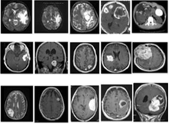

Figure 1.1 MRI image

## 1.3 Problem Statement

Healthcare sector is totally different from other industry. It is on high priority sector and people expect highest level of care and services regardless of cost. After the success of deep learning in other real-world application, it is also providing exciting solutions with good accuracy for medical imaging and is a key method for future applications in health sector. Brain is an organ that controls activities of all the parts of the body. Recognition of automated brain tumor in Magnetic resonance imaging (MRI) is a difficult task due to complexity of size and location variability. In this project techniques are proposed to process the images obtained by MRI for Tumor Detection from Brain MRI Images. Long short term memory will be used to classify the performance of tumors part of the image. The results produced by this approach will increase the accuracy and reduce the number of iterations.

## 1.4 Aim And Objective

Early detection of brain tumors could prevent millions of deaths. Early detection of brain tumors using magnetic resonance imaging (MRI) can improve patient survival; MRIs show tumors more clearly, which can help with subsequent treatment.

The goal of this project is to develop a system that uses deep learning to detect brain tumors. (Densely Connected Networks and Long short term memory).

The **objectives** of this project are:

1. To design and train a model via python and tensor flow for brain tumor classification
2. To design a test model
3. To Create and design a local website

## 1.5 Justification Of The Study

# It's only natural that researchers took on this project to create a system that can detect brain tumors at an early stage and save lives. Especially in these challenging times.

# CHAPTER TWO LITERATURE REVIEW AND RELEVANT CONCEPTS

# 2.0 Literature Review

# This chapter describes the approaches that are related to our work.

## Ahmad, M., Ghani, M. U., & Abdullah, M. T. (2021) Ahmad, Ghani, and Abdullah (2021) introduced a context-aware 3D UNet model for brain tumor segmentation, which has significantly advanced the field by incorporating spatial context into the segmentation process. Their approach integrates attention mechanisms to focus on the relevant parts of the brain MRI scans, improving the precision and robustness of the segmentation. The model leverages multi-scale information, allowing it to capture fine details and global context simultaneously, resulting in enhanced segmentation accuracy.

## Abiwinanda, N., Hanif, M., Hesaputra, S. T., Handayani, A., & Mengko, T. R. (2018) Abiwinanda et al. (2018) developed a convolutional neural network (CNN) tailored for brain tumor classification, which demonstrated remarkable performance in differentiating between various types of brain tumors. The model's architecture was specifically designed to handle the high variability in tumor appearance and size, utilizing a combination of convolutional layers and fully connected layers to extract and classify features effectively. This approach set a new standard for brain tumor classification, providing a robust framework for future research in this domain.

## Gumaei, A., Hassan, M. M., Hassan, M. R., Alelaiwi, A., & Fortino, G. (2021)Gumaei et al. (2021) proposed a hybrid feature extraction method combined with a regularized extreme learning machine (ELM) for brain tumor classification. This innovative method integrates traditional handcrafted features with deep learning features, enhancing the model's ability to distinguish between benign and malignant tumors. The use of ELM for classification, which is known for its fast learning speed and good generalization performance, further contributes to the efficiency and effectiveness of the proposed method.

## Islam, M., Rajpoot, N., & Mahmud, M. (2020) Islam, Rajpoot, and Mahmud (2020) introduced a 3D Attention UNet model for brain tumor segmentation and survival prediction, emphasizing the importance of attention mechanisms in enhancing the segmentation accuracy. Their model incorporates a 3D attention mechanism that selectively focuses on the most relevant parts of the input data, improving the segmentation performance. Additionally, their work extends beyond segmentation by integrating survival prediction, offering a comprehensive tool for clinical decision-making.

## Pashaei, A., Sajedi, H., & Jazayeri, N. (2020)Pashaei, Sajedi, and Jazayeri (2020) presented a hybrid CNN-SVM method for brain tumor classification, combining the strengths of convolutional neural networks (CNNs) for feature extraction with the Support Vector Machine (SVM) for classification. This hybrid approach leverages the powerful feature learning capabilities of CNNs and the robust classification performance of SVMs, resulting in improved accuracy and reliability in brain tumor classification tasks. Their work highlights the potential of combining different machine learning techniques to enhance overall performance in medical image analysis.

## 2.1 Theoretical Concept Of Project

## 2.1.0 What Is The Brain?

The brain is an organ composed of a large mass of nerve tissue protected inside the skull. The brain plays a role in almost all of the body's major systems.

Some of its major functions include: - Sensory information processing

- Processing of sensory information.

- Regulation of blood pressure and breathing

- Hormone secretion

## 2.1.2 Anatomy And Function

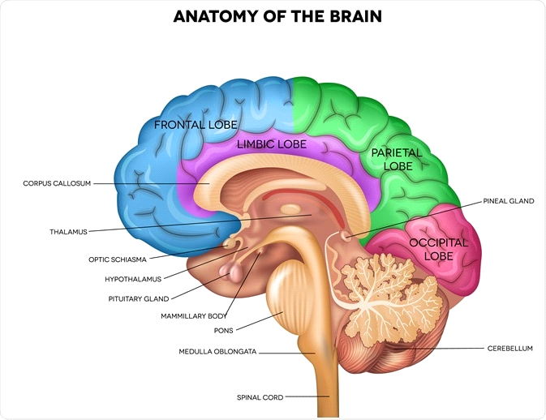

Figure 2.1 Brain structure

**Cerebrum**

The cerebrum is the largest part of the brain. The brain is divided into two parts called hemispheres.

The cerebral hemispheres are separated by a groove called a large longitudinal fissure. The corpus callosum connects the two hemispheres of the brain and allows the brain to transmit messages from one to the other.

Each hemisphere of the brain is divided into extensive areas called lobes. Each lobe is associated with a different function.

- Frontal lobe. The frontal lobe is the largest area of the lobes. As the name implies, it is located at the front of the brain. It coordinates high-level behaviors such as motor skills, problem solving, judgment, planning, and attention. The frontal lobe also controls emotions, personality, and temperament.

- Dark Lobe The dark lobe is located behind the frontal lobe. It is involved in organizing and interpreting sensory information from other parts of the brain.

- Temporal lobe (temporal lobe). The temporal lobe contains the auditory cortex. It is located on either side of the head, at the same level as the ears. It coordinates certain functions such as hearing, visual memory (e.g., face recognition), verbal memory (e.g., understanding language), and interpreting the emotions and reactions of others.

- Occipital lobe (occipital lobe) The occipital lobe is located at the back of the brain. It is largely responsible for the ability to read and recognize colors and shapes.

Cerebellum (cerebellum).

The cerebellum is located at the back of the brain, just below the occipital lobe. The cerebellum is involved in coordinating the fine movements of the arms, legs, and other body parts, known as "manual dexterity."

The cerebellum also helps maintain body posture, balance and equilibrium.

Intercerebral

The intercerebral system is located at the base of the brain. It includes.

- Thalamus (thalamus).

- Subthalamus

- Hypothalamus

- **Hypothalamus.**

The thalamus acts as a sort of relay of signals to the brain. It is also involved in arousal, pain perception, and attention.

The hypothalamus acts as a link between the limbic system and the rest of the brain. The limbic system is the part of the brain associated with emotions.

The hypothalamus processes information from the autonomic nervous system. The hypothalamus processes information from the autonomic nervous system and is responsible for controlling eating, sleeping, and sexual behavior. Specific functions of the hypothalamus include.

- Maintaining circadian physiological cycles, including the sleep-wake cycle

- Appetite regulation

- Regulation of body temperature

- Controls hormone production and secretion

**Brainstem.**

Before the cerebellum is the brain stem, connected to the spinal cord. It is responsible for transmitting messages to the various parts of the body and the cerebral cortex. It consists of three main parts.

- Midbrain. The midbrain is involved in controlling eye movements, processing visual and auditory information, regulating motor movements, and arousal and wakefulness.

- Cortex. The largest part of the brain stem. It is located below the midbrain. It contains the nerves that connect the various parts of the brain. The cerebral cortex is also the origin of several cranial nerves. These nerves are involved in facial movements, sensory information transfer, and breathing.

- **The medulla oblongata** The medulla oblongata is the lowest part of the brain. It is responsible for connecting the brain stem to the spinal cord. It also acts as the control center for the heart and lungs. It helps regulate many important functions, including motor and sensory functions, breathing, sneezing, and swallowing.

State of the brain.

There are hundreds of diseases that can affect the brain. Most fall into one of five major categories

- Cerebral injuries, such as concussion

- Cerebrovascular diseases, such as aneurysms and strokes

- Brain tumors, such as acoustic neuromas and schwannomas

- Neurodegenerative diseases such as dementia, Parkinson's disease and Huntington's disease

- Mental disorders such as anxiety, depression and schizophrenia

Our project will focus on brain tumors.

## 2.1.3 Brain Tumor

Brain tumors can be cancerous (malignant) or noncancerous (benign). As a benign or malignant tumor grows, the pressure inside the skull can increase. This can cause brain damage and can be life-threatening.

Brain tumors are classified as primary or secondary.

- Primary brain tumors are tumors that arise in the brain. Most primary brain tumors are benign.

- Secondary brain tumors, also known as metastatic brain tumors, occur when cancer cells spread to the brain from other organs, such as the lungs or chest.

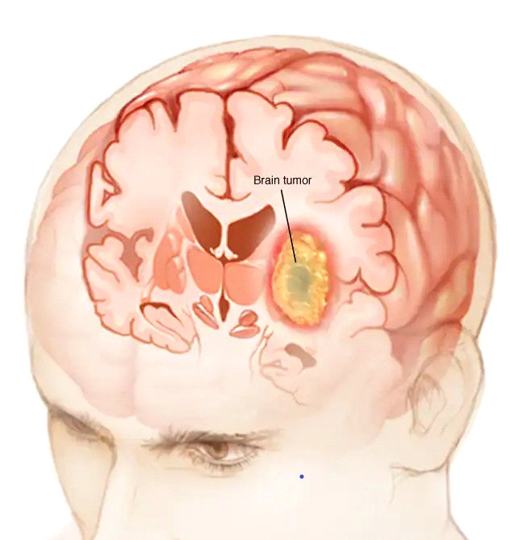

*Figure 2.2: Brain tumor images*

Benign and malignant brain tumors

**Benign brain tumors** can cause a number of serious problems, but they do not become cancerous. This means they grow slowly and usually do not spread to other tissues.

They also have clear borders, which makes them easy to remove surgically, and they don't recur after removal.

**Malignant brain tumors**, on the other hand, can become cancerous, growing quickly and spreading to other parts of the brain and central nervous system, causing life-threatening complications.

**Types of brain tumors**

**Primary brain tumors**

Primary brain tumors are tumors that arise in the brain. They can also arise from within your

- Brain cells

- The membrane that surrounds the brain (called the meninges).

- Neurons.

- Glands, such as the pituitary gland and pineal gland.

Primary tumors can be benign or cancerous. In adults, the most common brain tumors are gliomas and meningiomas.

Gliomas (gliomas)

Gliomas are tumors that arise from glial cells. These cells usually

- Support the structures of the central nervous system

- Supply nutrients to the CNS

- Remove cellular debris

- Destroying dead nerve cells.

Gliomas can arise from different types of glial cells.

Types of tumors arising from glial cells include.

- Astrocytic tumors, such as astrocytomas (arising in the brain).

- Oligodendrogliomas (oligodendroglial tumors): most commonly occur in the temporal lobe of the frontal lobe.

- Glioblastomas: arise from the supporting tissue of the brain and are the most aggressive type.

**Secondary brain tumors**

Secondary brain tumors make up the majority of brain tumors. These are those that arise in one part of the body and spread to the brain. Those that can metastasize to the brain include

- Lung cancer

- Breast cancer

- Kidney cancer

- Skin cancer

Secondary brain tumors are always malignant. Benign tumors do not spread from one part of the body to another.

**Risk factors for brain tumors include.**

Family history: Only about 5 to 10 of all cancers are genetically inherited, i.e., inherited. Brain tumors are rarely inherited.

Age : The risk of most types of brain tumors increases with age.

Exposure to chemicals :Exposure to certain chemicals, such as in the work environment, can increase the risk of developing brain tumors. The U.S. National Institute for Occupational Safety and Health compiles a list of carcinogenic chemicals present in the workplace.

Exposure to radiation. People exposed to ionizing radiation are at increased risk of developing brain tumors. You can be exposed to ionizing radiation when you are treated for cancer with high doses of radiation. There is also radiation exposure from radioactive fallout. The Fukushima and Chernobyl accidents are examples of how people can be exposed to ionizing radiation.

No history of chickenpox: According to a 2016 review published in Cancer Medicine, having had chickenpox as a child reduces the risk of developing glioma.

**Symptoms of brain tumors**

Symptoms of brain tumors depend on the size, location, and type of tumor.

Common symptoms of a brain tumor may include

- Headache

- Nausea or vomiting

- Loss of motor coordination, such as difficulty walking

- Drowsiness

- Feelings of weakness

- Changes in appetite

- Seizures or fits

- Impaired vision, hearing, or speech

- Loss of concentration

- Sudden changes in mood or behavior

**How a brain tumor is diagnosed.**

Diagnosing a brain tumor begins with a physical exam and history. During the physical exam, a very detailed neurological examination is done. The doctor will do an examination to check for any abnormalities in the cranial nerves. This nerve originates in the brain. The doctor will look into your eye with an ophthalmoscope, a device that shines through the retina through the pupil. This allows them to see how the pupil responds to light. Direct observation of the eye can also confirm the presence of optic nerve swelling. Increased pressure in the skull can cause changes in the optic nerve.

Your doctor may also assess your

- Muscular strength

- Coordination

- Memory

- Ability to do math calculations

Your doctor may prescribe additional tests after you complete your physical exam. These may include. Computerized tomography of the head

A CT scan is a more detailed scan than a doctor can perform with an X-ray machine. This scan may or may not include the use of a contrast agent. A CT scan of the head uses a contrast agent with a special dye that helps doctors see structures such as blood vessels more clearly.

**MRI scans of the head**

A head MRI uses special dyes to help doctors detect tumors; unlike a CT scan, an MRI does not use radiation, and it usually gives a more detailed image of the brain structures themselves.

**Angiography.**

In this test, dye is injected into an artery, usually in the groin. The dye is directed into the arteries of the brain. This allows the doctor to see the blood supply to the tumor. This information comes in handy during surgery.

**Skull X-ray**

Brain tumors can cause skull fractures, which can be confirmed by a special X-ray. This x-ray may also reveal calcium deposits that may be present in the tumor. If the cancer has spread to the bones, calcium deposits may be in the bloodstream.

**Biopsy.**

In a biopsy, a small piece of the tumor is taken. A specialist, called a neurologist, examines it. The biopsy can determine if the tumor cells are benign or malignant. It also determines whether the cancer originated in the brain or elsewhere in the body.

**Treatment of brain tumors**

Treatment for brain tumors depends on

- Tumor type

- Tumor size

- Tumor size and location

- Your medical condition.

The most common treatment for malignant brain tumors is surgery. Its goal is to remove as much of the cancerous tumor as possible without damaging healthy parts of the brain.

Some tumors can be safely removed depending on their location, while others may be in areas where the amount of tumor to remove is limited. Even partial resection of brain tumors can be beneficial. Risks of neurosurgery include infection and bleeding. Clinically dangerous benign tumors may also undergo surgical resection. Metastatic brain tumors are treated according to guidelines specific to the original cancer type.

Surgery is sometimes combined with other treatments, such as radiotherapy or chemotherapy.

Physical therapy, occupational therapy, and speech therapy are useful for recovery from neurosurgery.

## 2.1.4 Magnetic Resonance Imaging

Magnetic resonance imaging is a medical imaging technique used in radiology to image anatomical and physiological processes in the body; MRI scanners use strong magnetic fields, magnetic field gradients, and radio waves to produce images of organs in the body. Unlike other methods such as computed tomography (CT), X-ray, and positional emission tomography (PET), magnetic resonance imaging (MRI) has become the standard noninvasive method of diagnosing brain tumors in recent decades because it does not use harmful radiation and provides improved soft tissue contrast. MRI images are essentially a matrix of characteristic pixels.

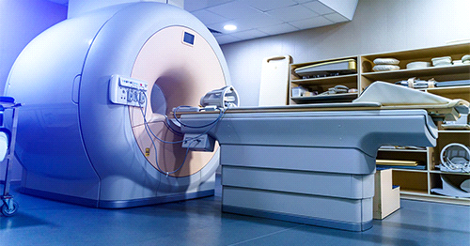

Figure 2.3 MRI DEVICE

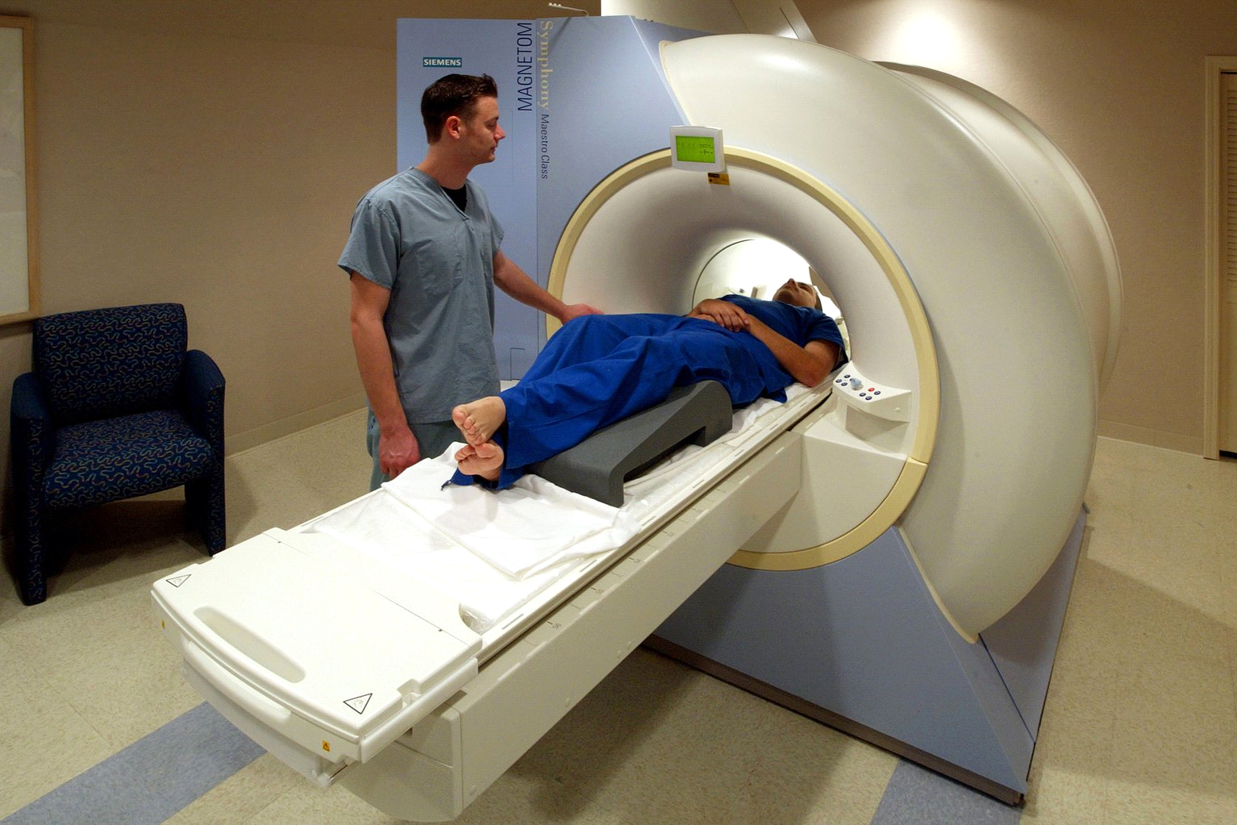

Figure 2.4 subject placement

**How magnetic resonance imaging works**

The human body is largely composed of water molecules, which are made up of hydrogen and oxygen atoms. At the center of the hydrogen atom is an even smaller particle called a proton. Protons are like tiny magnets and are very sensitive to magnetic fields. When you lie under the powerful magnets of the scanner, the protons in your body line up in one direction, like a magnet pulling a compass needle. A short period of radio waves is then sent to a specific place in the body to shift the position of the protons. When the radio waves stop, the protons are re-aligned. The radio waves are then transmitted and received by the receiver.

This signal gives the exact position of the protons in the body. It also helps to distinguish between different tissue types in the body. This is because different types of tissue align protons at different rates and produce different signals. Just as millions of pixels on a computer screen create a complex image, signals from millions of protons in the body can be combined to produce a detailed image of the body.

**What does an MRI scan of the brain show?**

An MRI of the brain or head shows the following structures in your head

- Your brain.

- The blood vessels connected to your brain.

- Your skull and facial bones.

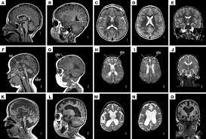

Figure 2.5 MRI image of brain

**MRI Results Interpretation**

MRI results can be interpreted in two ways

* BY A RADIOLOGIST
* BY A DIGITAL IMAGE PROCCESSOR

RADIOLOGIST

radiologist is a medical doctor who specilaises in diagnosing and treating injuries and diseeases and injury, using medical imaging technique such as x-rays, computed tomography(ct), magnetic resomamce imaging(mri), mammgram etc By looking at MRI images, your doctor can see details of blood flow and fluids surrounding the brain, which can help determine abnormalities in the brain relating to arteries and veins. An MRI brain scan also shows brain lesions.

## 2.2 Digital Image Proccessor

Digital Image Processing is the algorithmic processing and manipulation of digital images using digital computers. As a subdiscipline in the field of signals and systems, but with a focus on images, DIP focuses on the development of computer systems capable of performing image processing. The system inputs a digital image, which is then processed by an efficient algorithm to produce an image output.

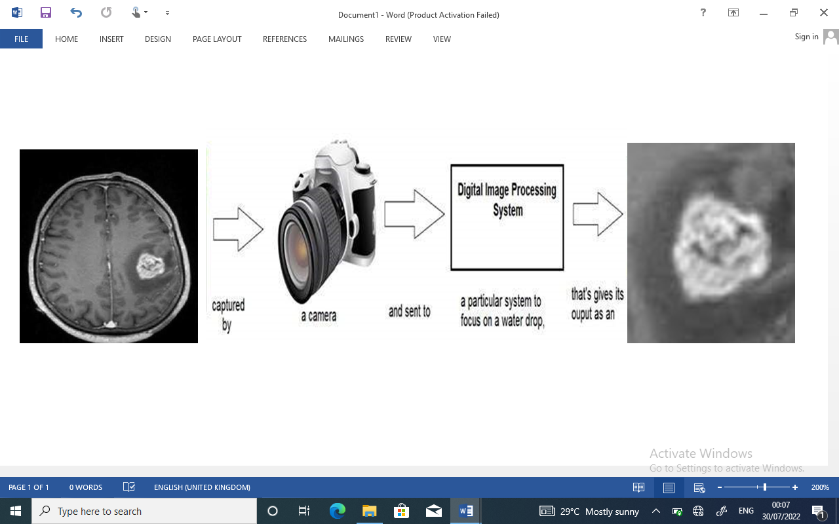

In the diagram above, the image taken by the camera is sent to the digital system, which removes all other details and focuses only on the tumor, zooming in so that the image quality remains unchanged. Digital image processing deals with signal processing as part of the process.

**Signal Processing**

Signal processing is a field of electrical engineering that specializes in analyzing, modifying, and synthesizing signals and deals with signal storage, filtering, and other operations on signals. Signals include transmission signals, audio signals, image signals, and other signals.

Of these signals, image processing is a field that deals with signals where the input signal is an image and the output signal is also an image. As the name implies, it deals with image processing.

It is also divided into analog image processing and digital image processing.

**Analog Image Processing**

Analog image processing is the processing done on analog signals; it also includes the processing of two-dimensional analog signals. It manipulates images using electrical means, changing the electrical signals. A common example is television images.

Digital image processing has gained an advantage over analog image processing over time because of its wide range of applications.

## 2.2.1 Digital Image Processing

Digital image processing deals with the development of digital systems that perform operations on digital images.

**What is an image?**

An image is nothing more than a two-dimensional signal. An image is defined by a mathematical function f(x,y), where x and y are two coordinates, horizontal and vertical.

The value of f(x,y) at any point gives the pixel value at that point in the image.

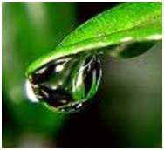

The diagram above is an example of the digital image you see now on your computer screen. But the image is really just a two-dimensional array of numbers from 0 to 255.

|  |  |  |
| --- | --- | --- |
| 128 | 230 | 123 |
| 232 | 123 | 321 |
| 123 | 77 | 89 |
| 80 | 255 | 255 |

Each value represents the value of the function f(x,y) at a given point. In this case, the values 128, 230 and 123 represent the values of the individual pixels, respectively. The size of the image is actually the size of this two-dimensional array.

**The relationship between digital images and signals**

If an image is a two-dimensional array, how is it related to signals? To understand this, we first need to understand what a signal is.

Signals.

Any quantity that can be measured in time, space, or higher dimensions can be considered a signal. Signals are mathematical functions and convey certain information.

Signals can be one-dimensional, two-dimensional, and higher dimensional signals. One-dimensional signals are signals measured in time. A common example is a speech signal.

Two-dimensional signals are signals that are measured over some other physical quantity. An example of a two-dimensional signal is a digital image.

**Relationship**.

In the physical world, anything that conveys information or a message between two observers is a signal. Speech (the human voice) and images are also part of signals. When we speak, our voice is converted into sound waves/signals, which are then converted in time and transmitted to the other person. Signals are also transmitted from one part of the system to another when we take an image with a digital camera.

**Image**

An image is two-dimensional and is therefore defined as a two-dimensional signal. The image has only length and width. The image has no depth. See image below.

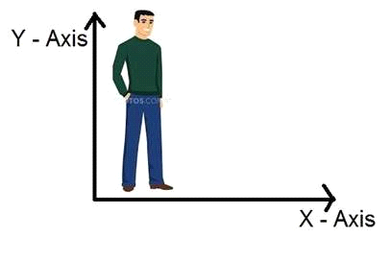

The diagram above shows that there are only two axes: vertical and horizontal. This makes it impossible to perceive depth. That is why we say that an image is a two-dimensional signal.

So an image is a two-dimensional signal and has two dimensions. Mathematically this can be expressed as follows.

F (x , y) = image

where x and y are two variables.

**Image formation**

A CCD (Charge-Coupled Device) sensor array is used to form an image; CCD stands for "charge-coupled device". Like other sensors, it is an image sensor that picks up values and converts them into electrical signals, e.g. in the case of CCDs.

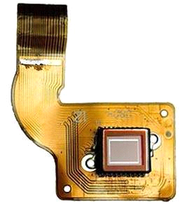

Figure 2.6 CCD

This CCD is actually an array or rectangular grid. It is like a matrix, and each cell in the matrix has a sensor that senses the intensity of the photons. Since the image is a two-dimensional signal and the CCD array is formed in two dimensions, a complete image can be obtained from this CCD array.

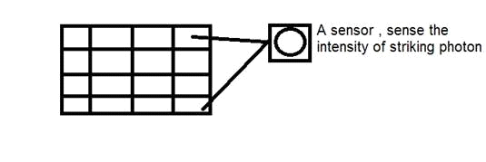

Figure 2.7 CCD Sensor array

Because of the limited number of sensors, there is a limit to the amount of detail that can be captured. Also, each sensor can only have one value for each photon that strikes it. Therefore, the number of photons (current) that hit it is counted and stored. To measure this accurately, an external CMOS sensor may be attached to the CCD array.

**Pixels**

The value of each sensor in a CCD array is the value of an individual pixel. Number of sensors = number of pixels. It also means that each sensor has only one value.

A pixel is the smallest component of an image. Each pixel corresponds to any one value; in an 8-bit grayscale image, a pixel has a value between 0 and 255. The value of a pixel corresponds to the intensity of the photons that hit that point. Each pixel stores a value proportional to the intensity of the light at that particular location.

The smallest division of a CCD array is called a pixel; each section of the CCD array stores a value corresponding to the intensity of the photons that hit it. This value is sometimes referred to as the pixel.

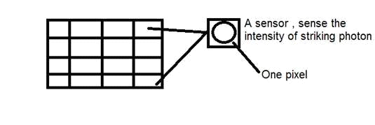

Counting the total number of pixels

An image is a two-dimensional signal or matrix. In this case, the number of PELs (the smallest discrete components of the image, also called pixels) is equal to the number of rows multiplied by the number of columns.

Mathematically this can be expressed as follows.

Total number of pixels = number of rows (X) number of columns.

**Image accumulation**

The charge stored in the CCD matrix is converted into voltage one pixel at a time. This voltage is converted into digital information using additional circuitry and stored.

## 2.2.2 Type Of Image

**Raster Image**

Bitmap images are made up of a series of pixels, or individual blocks, that make up an image; JPEG (JPG), GIF, and PNG are all extensions of bitmap images. All photographs found on the Internet and in print are bitmaps. Pixels have certain proportions depending on the resolution (high or low), and if they are stretched to fill a space in which they should not fit, the image will be distorted, blurry or fuzzy.

To preserve pixel quality, raster images cannot be resized without affecting resolution. Therefore, it is important that bitmap files be saved with the exact dimensions needed for their intended use. JPG files are used for this project.

They are considered raster images because they lose quality when zoomed out; JPEGs lose quality when zoomed out and can become blurry or pixelated when zoomed in beyond the size at which they were saved.

JPEGs can be used for a variety of projects, especially photos for Web sites and print publications. To create high-quality projects, it is important to pay attention to file size and JPEG resolution. Note that the file name extensions .jpg and .jpeg stand for the same thing. You can see both designations in image processing programs.

## 2.2.3 Applications and Uses of Image Processing

Some of the main areas in which digital image processing is widely used include

- **Machine vision and computer vision**

- Image sharpening and restoration

- Medical fields

- Remote sensing

- Transmission and encoding

- Robot vision

- Color processing

- Image processing

- Microscope image processing

- Pattern recognition

## 2.3 Machine/Computer Vision

Computer vision is a field of study which enables computers to replicate the human visual system. It focuses on creating digital systems that can process, analyze, and make sense of visual data (images or videos) in the same way that humans do. It’s a subset of artificial intelligence which collects information from digital images or videos and processes them to define the attributes. The entire process involves image acquiring, screening, analysing, identifying and extracting information. This extensive processing helps computers to understand any visual content and act on it accordingly.

Computer vision projects translate digital visual content into explicit descriptions to gather multi-dimensional data. This data is then turned into computer-readable language to aid the decision-making process. The main objective of this branch of [artificial intelligence](https://www.mygreatlearning.com/blog/top-10-hot-artificial-intelligence-technologies/?amp) is to teach machines to collect information from pixels.

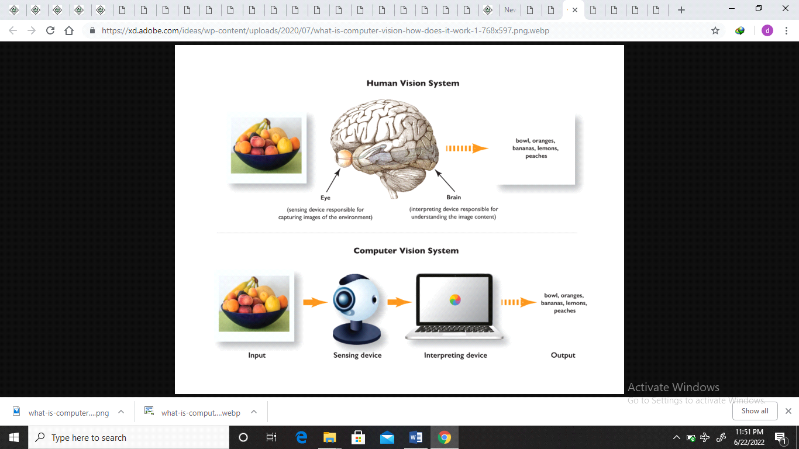

Figure 2.3.1 human and computer vision

## 2.3.1 Artificial Intelligence (Ai)

Artificial Intelligence (AI) is the imitation by machines, especially computer systems, of human intelligence processes, allowing them to mimic human behavior. It finds application in fields such as computer vision, natural language processing, robotics, and speech recognition. The term is often applied to projects to develop systems with human-specific intelligent processes, such as reasoning, meaning discovery, generalization and learning from past experience, etc. Since the development of digital computers in the 1940s, programming computers to, for example, discover proofs of mathematical theorems has been made possible by intelligent systems development projects. It has been demonstrated that computers can perform very complex tasks, such as finding proofs of mathematical theorems or playing chess, with a very high degree of competence. However, despite the ever-increasing processing speed and memory capacity of computers, there are still no programs that can match the flexibility of humans in tasks that require a great deal of broader and everyday knowledge. On the other hand, some programs have performance comparable to human experts and professionals when performing certain tasks.

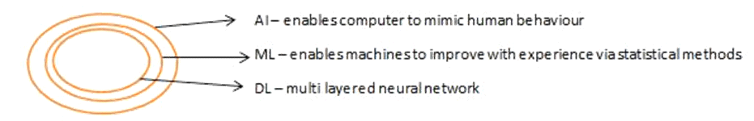

Figure 2.3.2 sub-classes of Artificial Intelligence

## 2.3.2 Machine Learning (Ml)

Machine learning (ML) is a subset of AI programmed to think independently, interact socially, acquire new information from given data, adapt and improve with experience. Machine learning is a process where a computer is given certain rules and tasks and decides for itself how to perform them. The machine starts without any knowledge and by trial and error comes up with a suitable solution. Neural networks are a typical example of machine learning.

## 2.3.3 Neural Networks

Neural networks are algorithms and data structures designed to allow machines to classify and predict outcomes based on a set of inputs. Neural networks have a structure similar to the brain. It consists of nodes (brain cells), connections, and weights, and operates on the principle of gradient descent. The network has two modes of operation. These are learning mode and output mode. In learning mode, a large number of data sets are fed to the input nodes and weights are adjusted. In output mode, unknown data is fed to the input nodes and the system suggests an output. Understanding neural networks is much broader, but here is a general overview. Neural networks are usually very complex and require enormous amounts of computing power to train.

Deep learning networks use neural networks within themselves. There are many similarities between the architecture of deep learning networks and neural networks. Both have input and output layers and both have learning and output modes. However, deep learning networks typically employ new innovations, such as convolution and McPooling, to make the algorithms run faster and allow for depth computation. In a nutshell, a deep learning network can be thought of as a network of neural networks.

Computer vision is the practice of transferring knowledge about the physical world around us to machines using sensors. Traditionally, this has been a very fragile and complex task, requiring special algorithms for pixel analysis. These algorithms were inflexible, had to be used in specific cases and were very sensitive to rotation and light. Recent advances in the speed and number of hardware graphics processors have allowed computer vision to use deep learning networks, which can mitigate the problems encountered with standard computer vision algorithms.

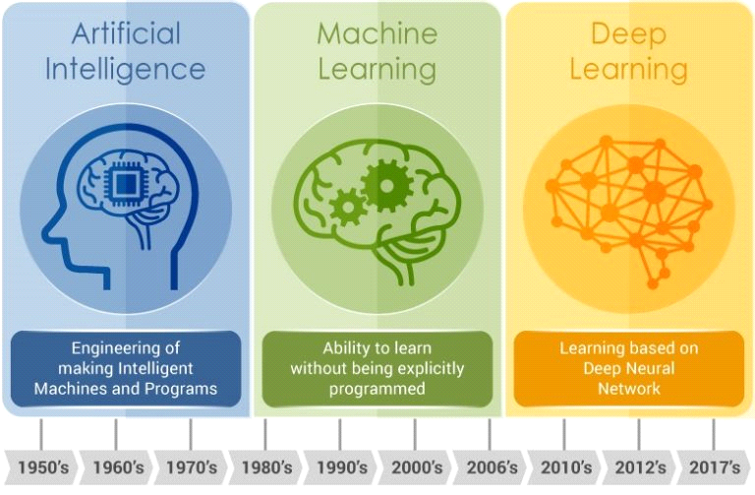

Computer vision is the application of machine learning and artificial intelligence to extract information from digital images and videos and make meaningful decisions based on that information.

Like many machine learning systems, computer vision requires huge amounts of data to train algorithms to interpret that data.

## 2.3.4 Deep Learning

Deep learning is a method (or subset) of machine learning that teaches computers to learn from examples as humans do. Deep learning is a key technology for driverless cars to recognize stop signs and distinguish between pedestrians and street lights. It is also the key to voice control in consumer devices such as cell phones, tablets, televisions and loudspeakers. Deep learning has been in the spotlight lately, and for good reason. Deep learning makes possible what was previously impossible.

In deep learning, computer models learn to perform classification tasks directly from images, text, and speech. Deep learning models can achieve the highest accuracy, sometimes even exceeding human-level performance. Deep learning models are trained using large amounts of labeled data and a neural network architecture containing multiple layers.

**Why does deep learning achieve such impressive results?**

It can be expressed in one word: precision. Deep learning achieves unprecedentedly high recognition accuracy. It helps devices meet user expectations and is also essential for mission-critical applications such as driverless cars. Recent advances in deep learning have reached the point where deep learning outperforms humans in some tasks, such as classifying objects in images.

Deep learning theory was first proposed in the 1980s, but only recently has it become useful for two main reasons.

- Deep learning requires large amounts of labeled data. For example, driverless car development requires millions of images and thousands of hours of video.

- Deep learning requires significant computing power. High performance GPUs have a parallel architecture that is efficient for deep learning. When combined with cluster computing and cloud computing, the learning time of deep learning networks can be reduced from weeks to hours.

# CHAPTER THREE

# METHODOLOGY

## 3.0 Introduction

The focus of this project is on computer-aided diagnosis of brain tumor by feeding brain tumor MRIs to LSTM/DENSENET model. Using labelled data (datasets), DENSENET extracts features and learns to classify images as positive or negative diagnosis of brain tumor by **LSTM**. This model of LSTM uses pre-processed images for a better performance. The main phases of this project include, gathering the latest brain tumor image dataset, pre-processing on images, gradual and incremental training of the model, and finally performance evaluation by testing the model. Tensorflow/keras is used for DENSENET/LSTM implementation.

## 3.0.1 Block Diagram

Figure 3.0.1 A high-level block diagram of the brain tumor recognition pipeline to implement task

## 3.1.1 Architectural Pipeline Design and Analysis

The Tensorflow architecture pipeline implemented for the task can be broken down in four distinct phases, which are condensed in Figure 3.0.1

1. **Data pre-processing**: loading a dataset in memory and processing it to gather image-label pairs for the classification task.
2. **Building the model** - build the model for the data
3. **Model training**: creating a LSTM model that can fit the data extracted by densenet to learn the training set samples. Predictions are carried out once the model finishes training on the validation and test sets.
4. **Result visualisation**: the model’s performance is evaluated by calculating various metrics and plotting predictions.

## 3.1.5.1 Data Pre-Processing

**What is data pre-processing?**

Data preprocessing is an element of data preparation that describes any kind of processing performed on raw data and prepares it for another data processing procedure. Traditionally, it plays an important role as a preliminary step in data mining. More recently, data preprocessing has been applied to training and reasoning about machine learning and AI models.

Data pre-processing transforms the data into a format that is more easily and effectively processed in data mining, machine learning and other data science tasks. The techniques are generally used at the earliest stages of the machine learning and AI development pipeline to ensure accurate results.

 There are six significant steps in data pre-processing:

**1. Acquire the dataset**

Acquiring a dataset is the first step in data preprocessing. In order to build and develop a machine learning model, an appropriate dataset must first be obtained. This dataset consists of data collected from several different sources that are combined in an appropriate format to form the dataset. The format of the dataset depends on the use case. For example, a business dataset is completely different from a medical dataset. Business data contains data from relevant industries and businesses, while medical data contains health-related data.

Kaggle datatset is used (www.kaggle.com/datasets)Python API to collect data and create a dataset. Once the dataset is created, it should be in CSV, HTML, or XLSX format. However, the dataset used in this study is in JPG format; it was obtained from kaggle.

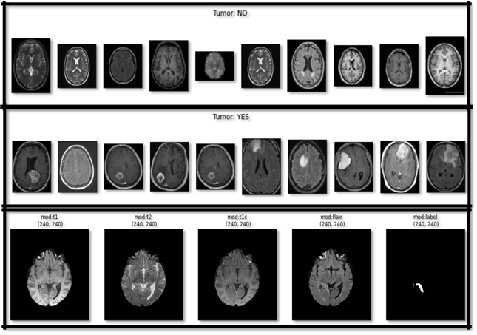

Figure 3.1.5.1 image of kaggle dataset

**2. Import all the crucial libraries**

Since Python is the most widely used and most preferred library for data scientists around the world, it was decided to import the Python library for preprocessing data in machine learning. The pre-installed Python libraries can perform certain data preprocessing tasks. Importing all important libraries is the second step in pre-processing data in machine learning. The three main Python libraries used for preprocessing data in machine learning are

- NumPy - NumPy is the basic package for scientific computing in Python. Therefore, it is used to insert all types of mathematical operations into your code; NumPy can also be used to add large multidimensional arrays and matrices to your code.

- Pandas - Pandas is an excellent open-source Python library for data manipulation and analysis. It is widely used for importing and managing datasets. It has high-performance, easy-to-use data structures and data analysis tools for Python.

- Matplotlib - Matplotlib is a Python two-dimensional plotting library used for plotting any type of graph in Python. It can provide publisher-quality plots in several printable formats and in interactive environments on different platforms (e.g. IPython shell, Jupyter notepads, web application servers).

**3. Import the dataset**

In this step, you need to import the dataset/s that you have gathered for the ML project at hand. Importing the dataset is important in data pre-processing in machine learning. However, before you can import the dataset/s,the current directory must be set as the working directory.

**4 feature extraction** which pulls out a relevant feature subset that is significant in a particular context. But its done by DenseNet.

**5 Splitting the dataset**

Splitting the dataset is the next step in data pre-processing in machine learning. Every dataset for Machine Learning model must be split into two different sets – training set and test set.

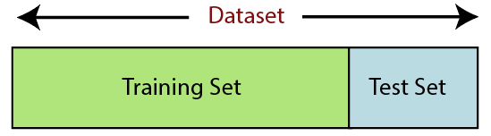

Training set denotes the subset of a dataset that is used for training the machine learning model. Here, you are already aware of the output. A test set, is the subset of the dataset that is used for testing the machine learning model. The ML model uses the test set to predict outcomes.

Usually, the dataset is split into 70:30 ratio or 80:20 ratio. This means that you either take 70% or 80% of the data for training the model while leaving out the rest 30% or 20%. The splitting process varies accordingly to the shape and size of the dataset in question.

**6 Feature scaling**

Feature scaling marks an end to**data pre-processing in Machine Learning(ML).** It is a method to standardize the independent variables of a dataset within a specific range. In other words, Feature scaling limits the range of variables so that they can be compared on a common basis.

## 3.1.5.2 Modelling

**Building the Model**

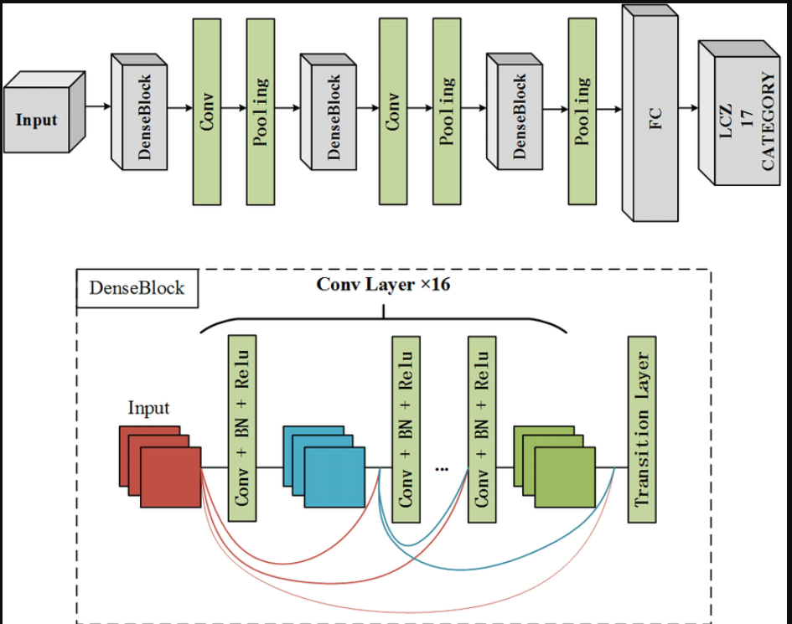

Figure 3.1.5.2 DENSENET architecture

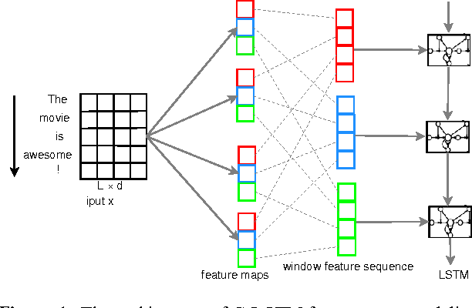

Figure 3LSTM architecture

Densely Connected Networks (DenseNet) and Long Short-Term Memory Networks (LSTM) are powerful deep learning models used for image classification and feature extraction. DenseNet is well-suited for processing lattice-structured data, like images, whereas LSTM excels at handling sequence data, capturing temporal dependencies. Both models can be leveraged in a hybrid approach for effective image classification.

**DenseNet**

DenseNet models consist of three different types of layers: convolutional layers, pooling layers, and fully connected layers. These layers perform feature extraction and classification tasks. The convolutional layers apply a series of mathematical operations to extract features from images. DenseNet uses a dense connectivity pattern, where each layer receives input from all preceding layers, improving gradient flow and parameter efficiency.

**LSTM**

LSTM networks are a type of Recurrent Neural Network (RNN) designed to overcome the vanishing gradient problem in long sequences. LSTMs are composed of memory cells that can maintain information for long periods, making them suitable for capturing temporal dependencies. By integrating LSTMs with DenseNet, we can enhance image classification by considering spatial and temporal features.

**Hybrid Model: DenseNet and LSTM**

The hybrid model combines the feature extraction capabilities of DenseNet with the sequence modeling strengths of LSTM. This approach can be particularly effective for image classification, where both feature and spatia information are crucial.

**DenseNet Components**

1. **Convolutional Layer**: This layer performs feature extraction by applying convolution operations on the input image. Convolution layers use filters (kernels) that slide over the image, capturing features like edges and textures. The mathematical operation involved is:

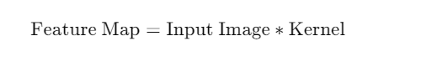

1. **Pooling Layer**: This layer reduces the spatial dimensions of the feature maps, decreasing computational complexity and mitigating overfitting. Max pooling and average pooling are common pooling techniques. The output dimensions after pooling can be calculated as:

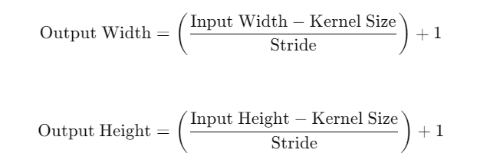

1. **Fully Connected Layer**: This layer connects every neuron in one layer to every neuron in the next layer. It is typically used at the end of the network to combine the features extracted by the previous layers for classification.
2. **Dropout**: This regularization technique helps prevent overfitting by randomly dropping units from the network during training. The dropout probability is a hyperparameter that needs to be tuned.
3. **Activation Functions**: These functions introduce nonlinearity to the network, enabling it to learn complex patterns. Common activation functions include ReLU, Sigmoid, and Softmax.

**LSTM Components**

1. **LSTM Cell**: An LSTM cell consists of a cell state and three gates: input gate, forget gate, and output gate. These gates regulate the flow of information, allowing the network to maintain long-term dependencies.
2. **Input Gate**: Controls how much of the new information flows into the cell state. It is calculated as:

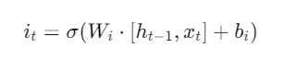

1. **Forget Gate**: Decides what information to discard from the cell state. It is calculated as:

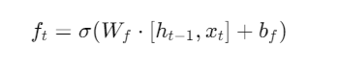

1. **Output Gate**: Determines the output of the LSTM cell. It is calculated as:



1. **Cell State Update**: The cell state is updated using the input and forget gates:



1. **Hidden State Update**: The hidden state is updated using the output gate and the new cell state:



**Implementation**

The hybrid DenseNet-LSTM model can be implemented as follows:

1. **Feature Extraction with DenseNet**: Use DenseNet to extract spatial features from the input images.
2. **Sequence Modeling with LSTM**: Feed the extracted features into an LSTM network to capture temporal dependencies.
3. **Classification**: Use fully connected layers and activation functions to classify the input based on the features extracted by DenseNet and LSTM.

**Conclusion**

Combining DenseNet and LSTM networks provides a robust approach for image classification and feature extraction. DenseNet excels at capturing spatial features, while LSTM is adept at handling temporal dependencies. This hybrid model leverages the strengths of both architectures, making it suitable for complex image classification tasks.

## 3.1.5.3 Training phase

After feature and spatial extraction by DenseNet and designing all the layers of the LSTM architecture, the sigmoid activation function is used to train the model. The sigmoid activation function is used as an optimizer to train the model. The training coefficient in the following equation is used as a loss function.

$$CE =-\sum_{i=1}^{c=m}{I_{i} log\left(s_{i}\right)=I_{i} log\left(s_{i}\right)-(1-}I_{i})\log\left(1-s_{i}\right)$$

Where *li* and *si* are the DENSENET scores for each positive and negative class, while the value of *m* is 2 (binary classifier).

**Training the Set**

The training set: It is the set of data that is used to train and make the model learn the hidden features/patterns in the data through epochs.

At each epoch, the same training data is repeatedly fed into the neural network architecture and the model continues to learn features of the data.

The training set should have a diverse set of inputs so that the model can be trained on any scenario and predict unknown data samples that may appear in the future.

**Epoch**

**An epoch means training the neural network with all the training-data for one cycle. In an epoch, we use all of the data exactly once. A forward pass and a backward pass together are counted as one pass:**

model is set.

For training LSTM for binary classification of brain tumor MRIs, cross entropy, given in

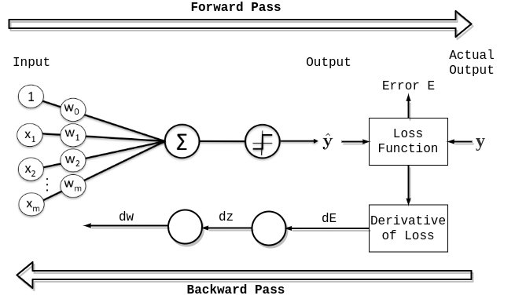

**An epoch is** made up of one or more batches, where we use a part of the dataset to train the neural network. We call passing through the training examples in a batch an iteration.

An epoch is sometimes mixed with an iteration. To clarify the concepts, let’s consider a simple example where we have 1000 data points as presented in the figure below**:**

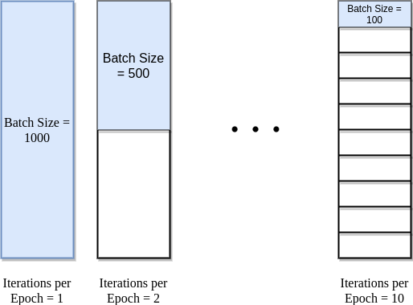

If the batch size is 1000, we can complete an epoch with a single iteration. Similarly, if the batch size is 500, an epoch takes two iterations. So, if the batch size is 100, an epoch takes 10 iterations to complete. Simply, for each epoch, the required number of iterations times the batch size gives the numbers of data point.

We can use multiple epochs in training. In this case, the neural-network is fed the same data more than once.

To train a neural network takes a considerable amount of time, even with current technology. If the number of epochs is set too low during the model building stage, learning stops before the model converges. Conversely, if the number of epochs is set too high, overfitting will occur. In addition, it wastes computational resources and time.

A widely adopted solution to this problem is to use early stopping. This is a type of regularization. **As the name suggests, the main idea in early stopping is to stop training when certain criteria are met. Usually, we stop training a model when generalization error starts to increase (model loss starts to increase, or accuracy starts to decrease).** To decide on the change in generalization errors, we evaluate the model on the validation set after each epoch.

By utilizing early stopping, we can initially set the number of epochs to a high number. This way, we ensure that the resulting model has learned from the data. Once the training is complete, we can always check the learning curve graphs to make sure the model fits well.

**The Validation Set**

The validation set this are sets of data, separate from the training set, that is used to validate our model performance during training.

This validation process gives information that helps us tune the model’s hyper parameters and configurations accordingly. It is like a critic telling us whether [the training](https://www.v7labs.com/training) is moving in the right direction or not.

The model is trained with the training set, and, simultaneously, the model evaluation is performed on the validation set after every epoch. The main idea of splitting the dataset into a validation set is to prevent the model from overfitting i.e., the model becomes really good at classifying the samples in the training set but cannot generalize and make accurate classifications on the data it has not seen before.

## 3.2 Software Requirements:

**Python 3** –Python, a statistical mathematical programming language, is used instead of MATLAB for the following reasons.

- Python code is more compact and readable than MATLAB

- Python's data structures are superior to MATLAB.

- It is open source and more graphics packages and datasets are available.

**Keras (with TensorFlow)** - Keras being a neural network API it consists of TensorFlow, CNTk, Theano, etc. Python packages were used for mathematical computations and graph plotting, including Numpy, Matplotlib, and Pandas; SimpleITK for loading .jpg format images; and Mahotas for feature extraction.

**Kaggle** was used to retrieve online datasets.

**GitHub and Stackoverflow** were used as references in case of programming syntax errors.

**OpenCV (Open Source Computer Vision)** is a library of programming functions for real-time computer vision that can read and write images, change image quality, remove noise by Gaussian blurring, binary thresholding of images, original images consisting of pixel values It is available in C++, Java, C, and Python, is free to use, and easy to learn. It is a popular application for web-based control repositories.

**Visual Studio Code** is a code editor redefined and optimized for building and debugging modern web and cloud applications.

**Streamlit** Streamlit is an open-source Python framework for data scientists and AI/ML engineers to deliver interactive data apps – in only a few lines of code.

**3.3 Hardware Requirements**

Processor: Intel® Core™ i7-2350M Nvidea GPU @ 2.82GHz

Installed memory (RAM):16.00GB

System Type: 64-bit Operating System.